**Learning Activity 2-12**

Design the relational model based on the entity-relationship (E/R) diagram of a database for the management of personnel and government of a city council. The description of the information system we have is as follows:

Their personal data (ID, name, surname, address, telephone number) is stored for all the people who currently work at the town hall.

The people of the town hall can be councilors, civil servants and labor personnel.

* For councilors, information is stored about the political group to which they belong, whether or not they are full-time, and the salary they receive.
* For civil servants, their access level, qualification, and date of entry are stored.
* For those belonging to the workforce, we have their contract data (contract date, type of contract, end date, daily work hours).
* A councilor can be an official or a member of the labor force. There cannot be a worker who is both an official and a worker.

Councilors can be appointed council representatives of a certain area.

* In an area there can be several representative councilors and there must necessarily always be one representative.
* A councilor may not be a representative in any area.
* For the position of representative, the date on which a councilor accepted that position must be stored.

Plenary sessions are held in the town hall. Information is recorded on all the plenary sessions held, not only those that included the current councilors. These plenary sessions have a date and time of completion and an agenda.

* For each plenary session, a record is drawn up.
* A plenary session may not have minutes when it has not yet been written.
* Each minute contains the agenda, the content of what was discussed in the plenary session, and the date of approval of the minute.
* The councilors who attend each plenary session must be controlled.

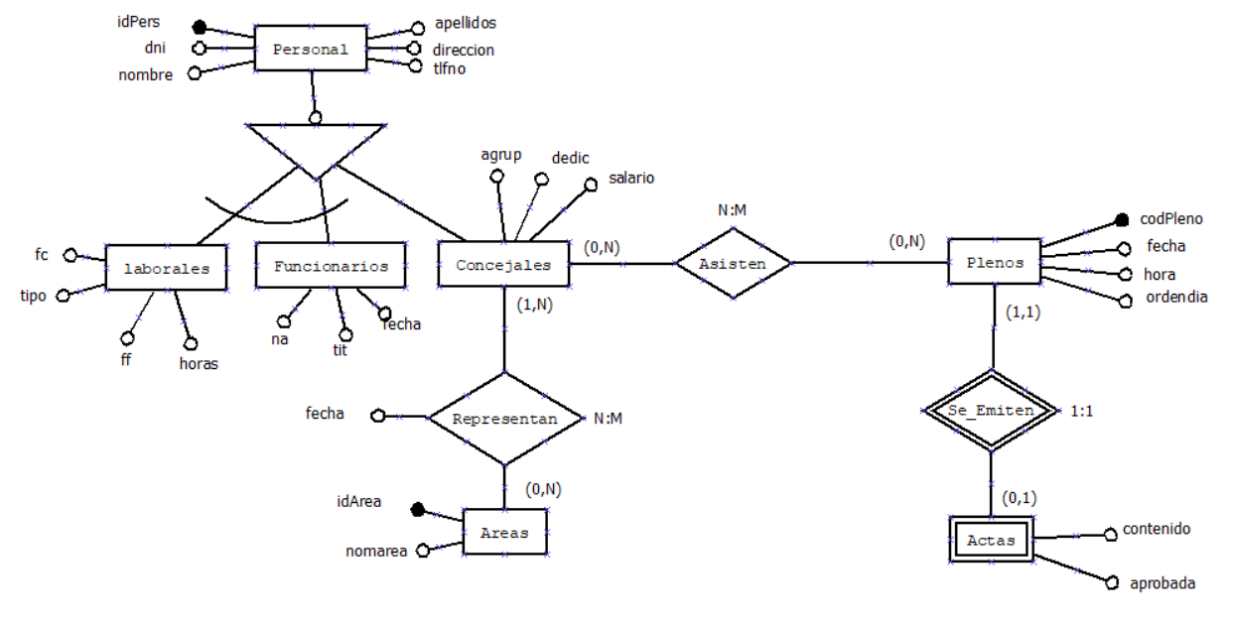

Keep in mind that a councilor who is an area representative cannot be deleted.

If a councilor who has attended a plenary session is modified, the null value must be set in said plenary session.

If a councilor representing an area is modified, said representation must also be modified.